

School of Computer Science, UPES, Dehradun.

A

Lab 3

On Software Engineering

B.TECH. - V Semester

**Submitted to:**

Dr. Hitesh Kumar Sharma

**Submitted by:**

Name: Ishika Mehrotra

Batch: Devops B1

Sap Id: 500124411

Roll No.: R2142230281

**Lab Exercise 3- Working with Git Rebase**

**1. Set Up the Repository**

**Commands:** echo "Line 1 from main branch" > file.txt

git add file.txt

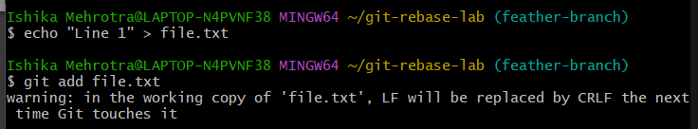

**2. Create a new branch feature-branch:**

**Commands:** git checkout -b feature-branch



**3.Add a new line to file.txt in feature-branch:**

**Commands:**

echo "Line 2 from feature branch" >> file.txt

git add file.txt

git commit -m "Add Line 2 from feature branch"

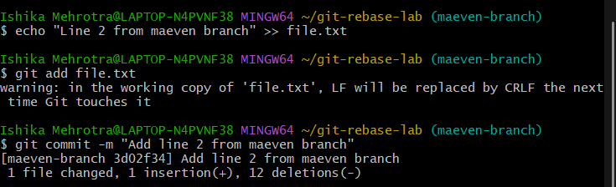

**4.Switch back to the main branch and add another line:**

**Commands:**

git checkout main

echo "Line 3 from main branch" >> file.txt

git add file.txt

git commit -m "Add Line 3 from main branch"

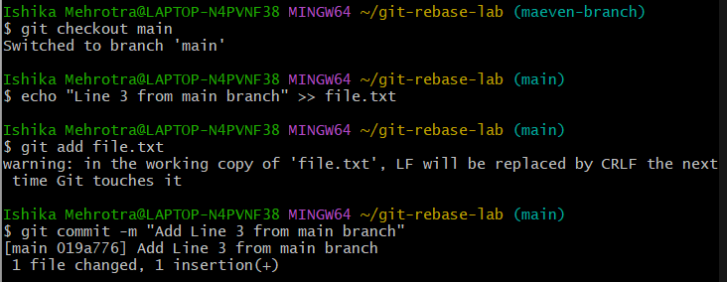

**5 .Switch to feature-branch:**

**Command:** git checkout feature-branch

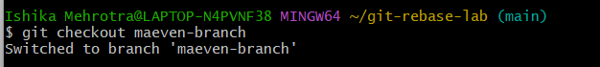

**6. Verify the Rebase:**

**Command:** git log –oneline

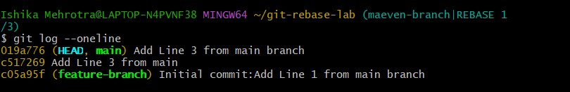

**7.Check the contents of file.txt:**

**Command**: cat file.txt

